|  |
| --- |
|  |
| Blue Pumpkin |
| Project Documentation of DISM (Semester II) |

**our team members**

* MAIB PERWAIZ Student1098868

**Faculty** = Miss Aatika Liaquat

**Batch Code** = 1803B2

**Curriculum**= 6673

**Semester**= HDSE-2

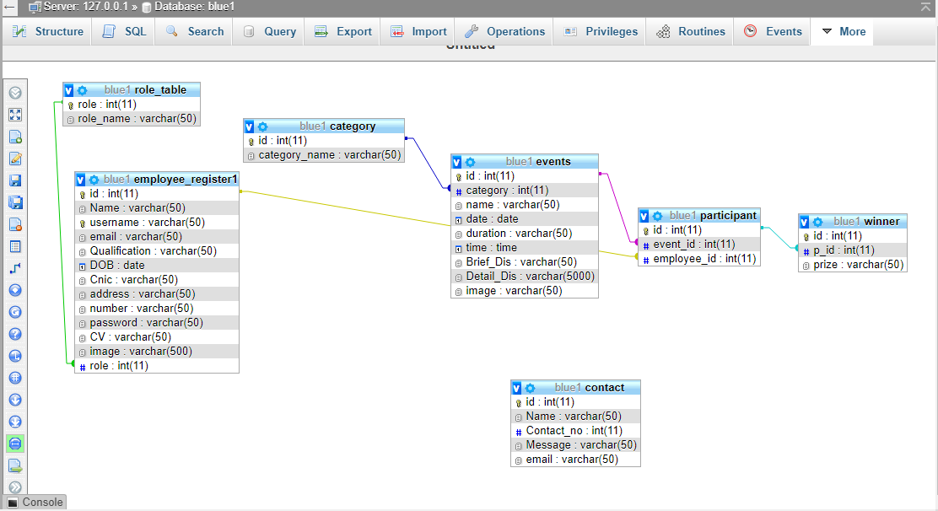

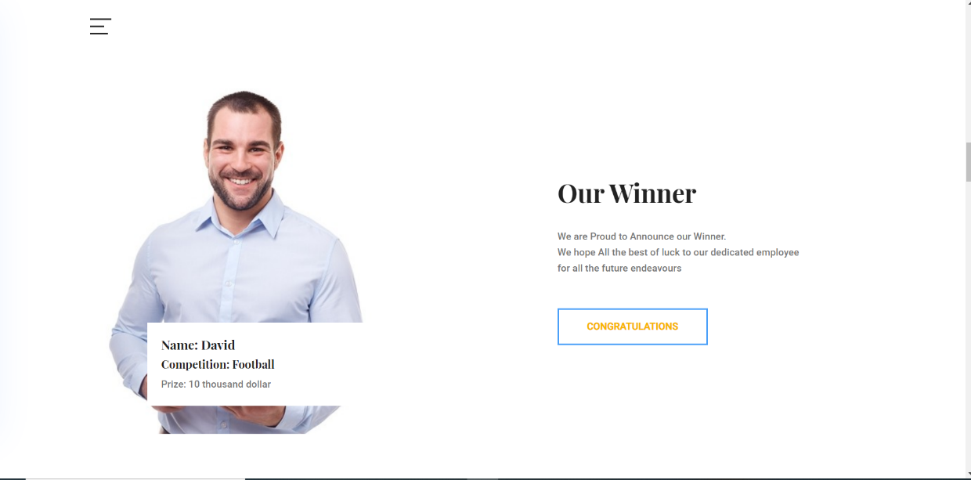

Code Snippet

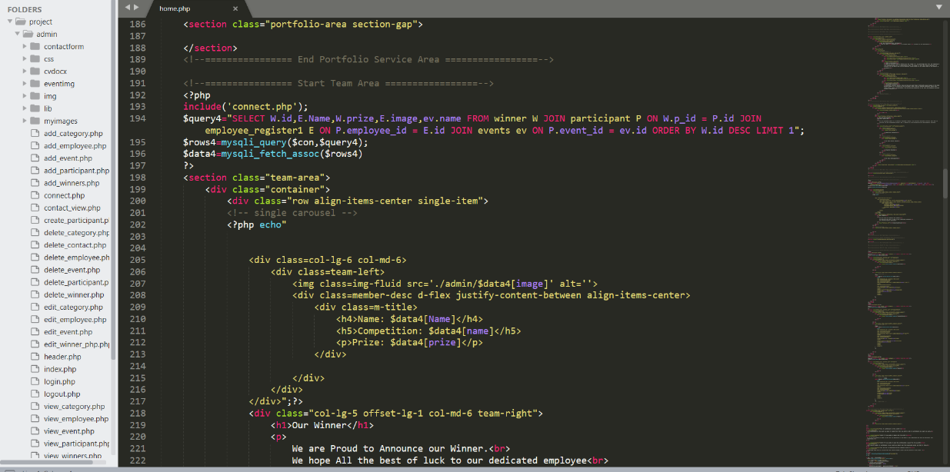

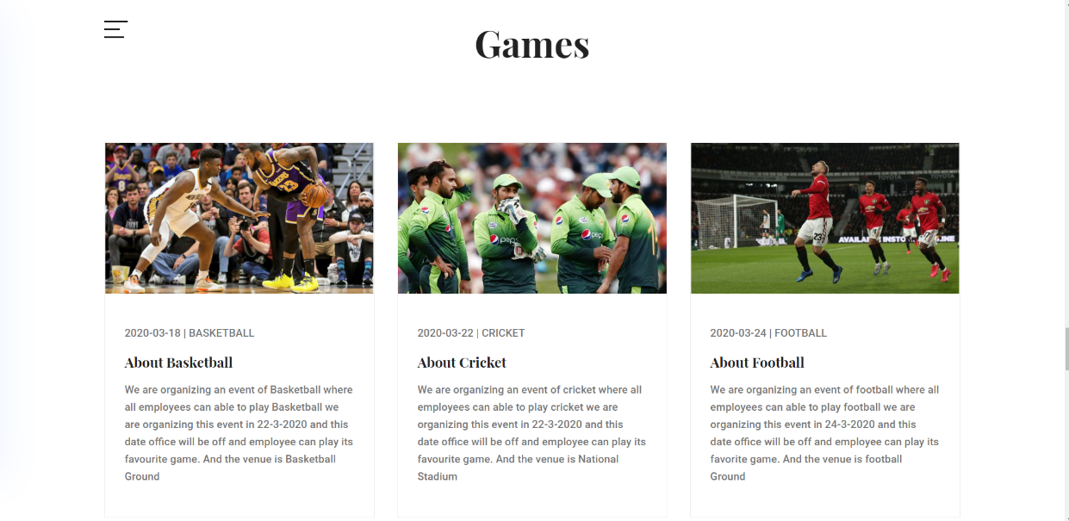

Code Snippet

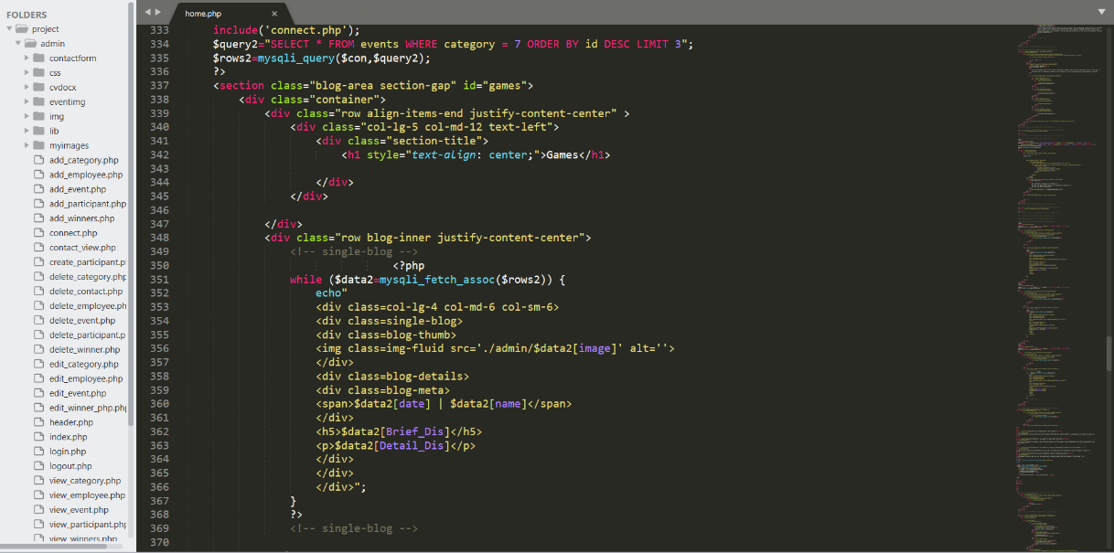



Login Page: -

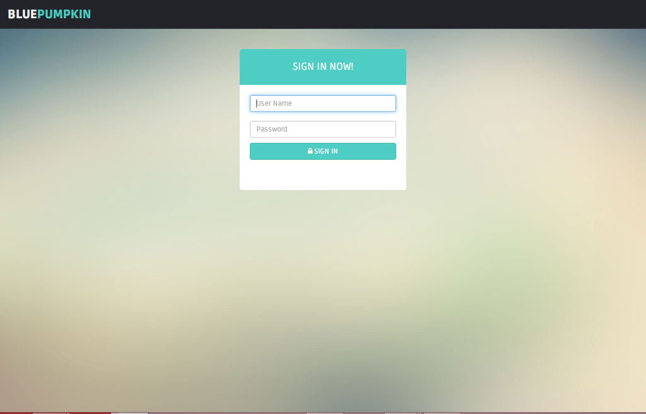

Code Snippet

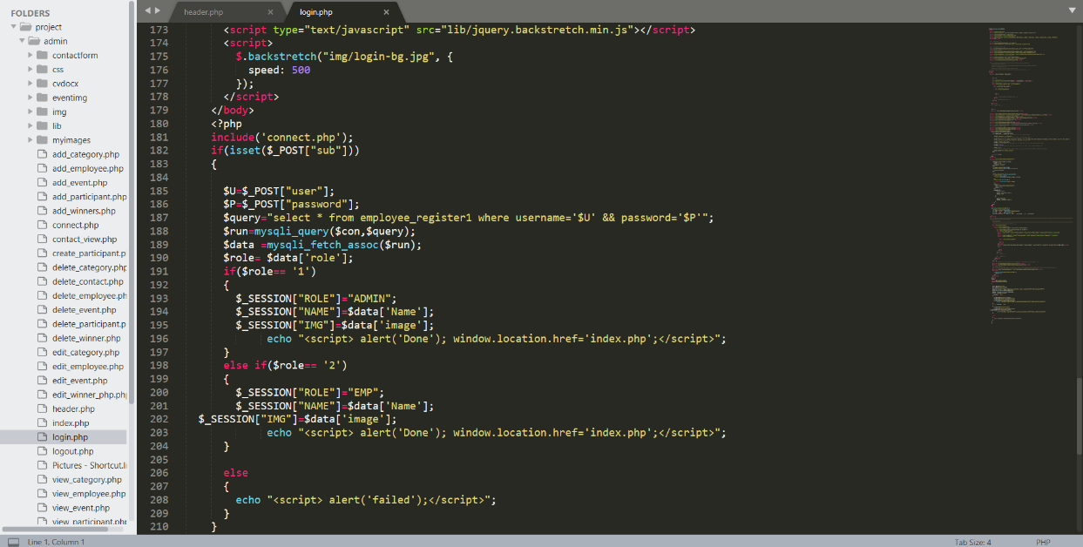



Employee :-

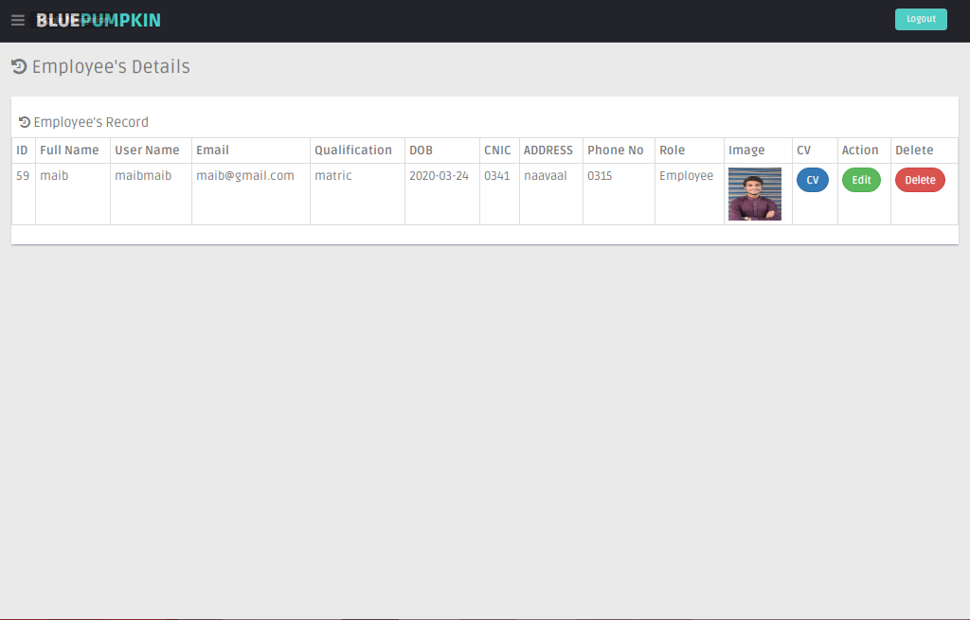

Code Snippet 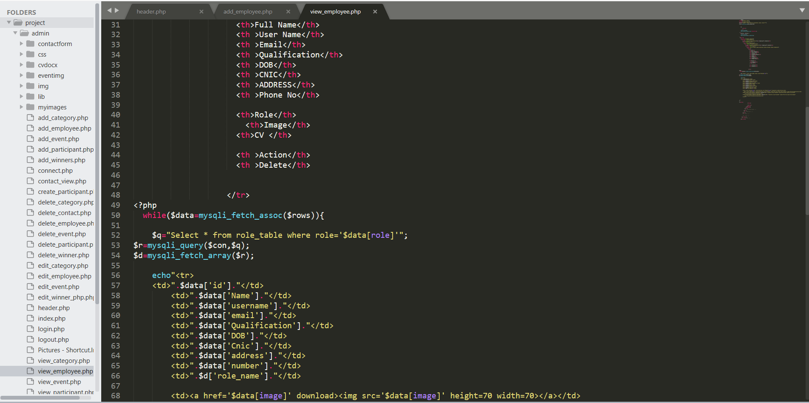



participant: -

.

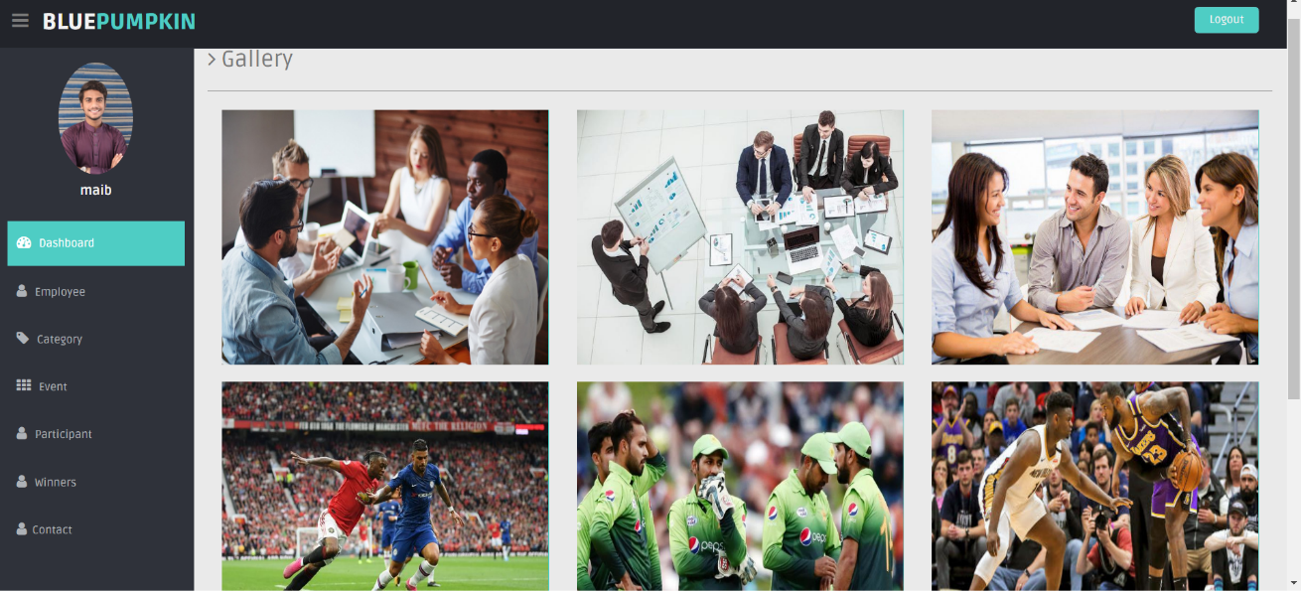

Code Snippet

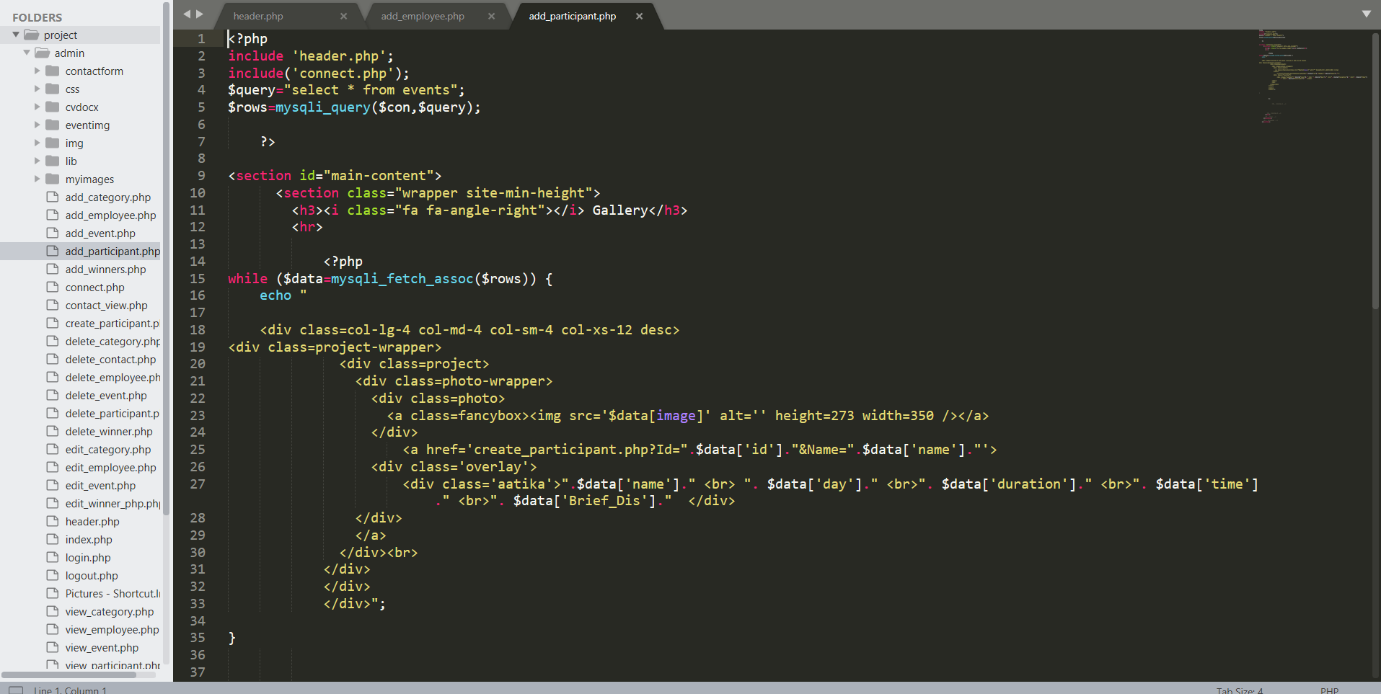



## 

Event : -

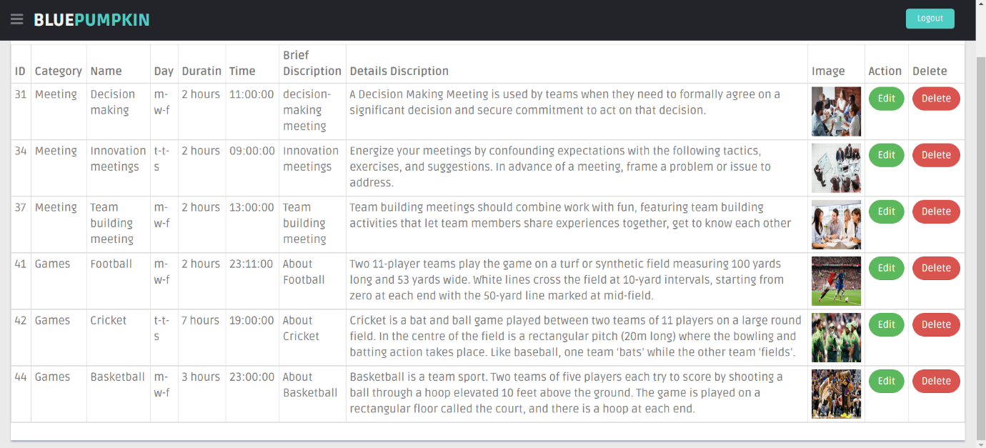

Code Snippet:-

